Point Of Sale Web Application

By

Noor Rashid Hameed

Supervisor

HTU technical (Bashara Stephane)

This Thesis was Submitted in Partial Fulfillment of the

Requirements for final project in

Full Stack PHP Web Development Degree

Deanship of Academic Research and Graduate Studies

HTU University

2023

|  |  |
| --- | --- |
| Subject | Page |
| Title | 1 |
| Table of Contents | 2 |
| List of Abbreviations | 3 |
| List of Figures | 3 |
| 1.1Introduction | 4,6 |
| Summary | 5 |
| 1.2 Previous studies | 7 |
| Methodology | 10 ,11 |
| Java | 22 |
| Implementation Selling dashboard using | 25 |
| Outline crud operation | 28 |
| the following 3 types of security are currently supported in POS | 29 |
| Conclusion | 33 |
| Reference | 34 |

List of Abbreviations

|  |  |
| --- | --- |
| POS | Point Of Sale |
| Oo p | Object Oriented programming |
| MVC | Model View Controller framework |
| Sys ML | System Model Language |
| XAMPP | package developed by Apache Friends |

List of Figures

|  |  |  |
| --- | --- | --- |
| Figure Number | Figure Title | Page |
| Figure (1) | Pos based MVC pattern | 16 |
| Figure (2) | Log in page | 18 |
| Figure (3) | Pos build using MVC design pattern | 19 |
| Figure (4) | profile on dashboard with update on photo | 20 |
| Figure (5) | stock management page contain all items | 20 ,21 |
| Figure (5.1) | One item | 21 |
| Figure (6) | users list | 22 |
| Figure (6.1) | Create user | 22 |
| Figure (7) | Selling dashboard.(Total sales ,Item , Quantity ,Price per unit, Total ). | 26 |
| Figure (8) | Selling dashboard Join with data transactions list ( same data in 2 pages ). | 27 |
| Figure (9) | Saving Selling dashboard in data base. | 27 |
| Figure (10) | security implement ( role (permission)) | 28 |
| Figure (11) | grant permission | 28 |
| Figure (12) | outline crud operating on project | 29 |
| Figure (13) | secured | 30 |
| Figure (14) | use permission with cookie ( ) | 31 |
| Figure (15) | represent procurement with permission with code password hash | 31 |
| Figure (16) | use security serialize and hash password | 32 |

Introduction

**Summary**

* Building POS Web Application:
* I designed Front End Web page using HTML, CSS which was implemented in Login Page.
* I used Front End Frame work and libraries through using bootstrap and jQuery which are implemented in all POS web application.
* I created API to handle AJAX requests, where it is implemented in SELLING Dashboard, Transaction Management and User Transaction.
* I created secured web apps be, no SQL injection attacks, no easy-to-read passwords, and no XSS vulnerabilities.
* I created web apps based on MVC design pattern that is implemented in all details within POS web application.
* I created roles of employees through determine in form (create, update users) and hard coded , where the app is controlled based on permissions.
* We will Improve POS Web Application using PHP MVC framework.
* Technology used:
* Database connection SQL query
* Session
* Cookies
* Better page controller that accept different page parameters, or any other feature can be added very easily, and this report (presentation) shows the way to build a really simple POS Web Application through PHP MVC.

**1.1 Introduction**

Architecture : is general has no specific recommendation on using special method or language.

MVC frameworks are widely used in the industry because they offer a lot of advantages for rapid and structured development. There are MVC frameworks for most of the programming languages you may know, from Dot Net to PHP.

the viewer sends updates to the controller, the controller updates the model, and the viewer updates directly from the mode

Think of the MVC design pattern as a car and the driver.

The car has the windscreens (view) which the driver (controller) uses to monitor traffic ahead then speed or brak

**Why use PHP MVC Framework?**

* PHP MVC Frameworks simplify working with complex technologies by;
  + Hiding all the complex implementation details
  + Providing standard methods that we can use to build our applications.
  + Increased developer productivity, this is because the base implementation of activities such as connecting to the database, sanitizing user input etc. are already partially implemented.
  + Adherence to professional coding standards.

What does mean MVC?

To designer POS, I will needed MVC is a design pattern used to decouple data (Models), the user-interfaces (Views), and application logic (Controllers). To be able to follow this “How to”, you need to have a good knowledge of PHP and OOP (Object Oriented Programming).

**-Requirement:**

To build a point of sale (POS) web application implemented & enhanced by Mvc and specified to handle the store (sales ,transaction & stock), and employees with different role in POS.

**1.2- Previous studies**

Build web application based on PHP MVC framework:

Independently you are using [Docker](https://www.docker.com/), XAMPP, or whatever for your development environment, let’s create a simple structure for the simple PHP MVC framework. I use to have a folder called “Core” for all my projects, then enter your folder, create a new folder called “Base- mvc and then enter that folder.  
Let’s create the basis folders for your MVC:

1. app
2. config
3. public
4. views
5. routes (index.php)

Starting small, let’s create the two most important files of our simple PHP MVC:

index. php and htaccess.

The htaccess configuration file

Enter the public folder, and let’s create a file called index. Php

Now, at the root level of your project, let’s create a new file called .htaccess  
Then open it, and put this code inside the htaccess:

Htaccess is a configuration file for the Apache web server, and tells to Apache that every request will end up to the index. Php

<IfModule mod\_rewrite.c>

#  you need to AllowOverride All in httpd.conf

    RewriteEngine On

    RewriteBase /

    #RewriteCond %{REQUEST\_FILENAME} !-d

    RewriteCond %{REQUEST\_FILENAME} !-f

    RewriteRule ^(.+)$ index.php [QSA,L]

</IfModule>

Inside the config file, we can store the settings of the framework, for example, we can store the name of our app, the path of the root, and of course, the database connection parameters:

<?php

//site name

define('SITE\_NAME', 'your-site-name');

//App Root

define('APP\_ROOT', dirname(dirname(\_\_FILE\_\_)));

define('URL\_ROOT', '/');

define('URL\_SUBFOLDER', '');

//DB Params

define('DB\_HOST', 'your-host');

define('DB\_USER', 'your-username');

define('DB\_PASS', 'your-password');

define('DB\_NAME', 'your-db-name');

Autoloader

We want to be able to load the future classes without any pain (see dozen of include or require), then we’ll use the  [autoloading](https://www.php-fig.org/psr/psr-4/)

It was reported that some hosting needs the *classmap*directive: *classmap****spL* autoloading** will recursively go through *.php* and *.inc* files in specified directories and files and sniff for classes in them.

In project the same but by Methodology different

As: use Core\Model\User;

use Core\Model\User;

use Core\Helpers;

use Core\Router;

this will used in all project -> Get name class & \ , (name space )

by function spl\_autload

<?php

session\_ start();

spl\_ autoload\_ register(function ($class\_name) {

    if (strpos($class \_name, 'Core') === false)

        return;

    $class\_name = str\_replace("\\", '/', $class\_name); // \\ = \

    $file\_path = \_\_DIR\_\_ . "/" . $class\_name . ".php";

    require\_once $file\_path;

});

Part code spl autoload in index. Php

**Methodology**

**Methodology**

Let us with three components of POINT OF SALE(POS) in brief:

1. **Model**: The Model encloses the clean application related data. But the model does not deal with any logic about how to present the data.
2. **View:** The View element is used for presenting the data of the model to the user. This element deals with how to link up with the model's data but doesn't provide any logic regarding what this data all about or how users can use these data.
3. **Controller**: The Controller is in between the model and the view element. It listens to all the incident and actions triggered in the view and performs an appropriate response back to the events.

**I designed this project**, founded it, and built it based on MVC. It contains a Router which is a class that takes all the routes we put inside the index file and the index .php that specifies the type of route, whether it is (get, post, put or delete)

Example

Router::get('/items', "items. index"); // list of items (HTML)

Code router in index. php , Index.php is contain router processing that get from on

Routes to perform CRUD operations .

* Manages the routing process (Requests types) in the application as following :

class Router

{    // GET requests

    protected static $get \_routes = array();

* **public static function redirect : ( handle with request)**
* Redirect is a function that determines the type of request based on the request of the **client** and determines if it is available or not. If it is available, it determines which router class will interact with this request, meaning it will handle the determined on any request .
* $class = $controller\_ namespace . $class \_name; (determine class name with name space (URL in project instead of require, use as / example : use ( core / model/items ).
* **Part of function redirect**

 public static function redirect (): void

    {

        $request = $\_SERVER['REQUEST\_URI'];

        $routes = array();

        switch ($\_SERVER['REQUEST\_METHOD']) {

            case 'GET':

                $routes = self::$get\_routes;

                break;

…….. . etc

  $controller namespace = 'Core\\Controller\\';

        $class\_arr = explode('.', $routes[$request]);

        $class\_name = uc first($class\_arr[0]);

        $class = $controller namespace . $class name;

        $ instence = new $class;

        if (count($class\_arr) == 2) {

            call\_user\_func([$instence, $class\_arr[1]]);

        }

        $instence->render();

    }

* **(self::) when we use a static method/property in the class .**
* ($this->) when we use the class as an instance (new) object .
* Get instance with render because always call function render when work model by instance render when access any class .

**Render**

* The render function is responsible for displaying by

## View

The view is responsible to take in the data from the controller and display those values.

* class view is Include the php html template in point of sale POS.

**class View**

{

        public **function --construct (string $view, array $data = array())**

**{**

            $view = str\_ replace('.', '/', $view);

            $data = (object) $data;

  Include \_once \ dirname(\_\_DIR\_\_, 2) . "/resources/views/$ view.php";

part of code class view in Core\Base\view. Php

**Model**

A model is an object that represents your data. The model will be modelled on your database table structure, and it will interact

**with the database operations (create, read, update and delete).**

**// CRUD OPERATIONS**

public function **create** (array $data) { }

public function **read** (int $id) { }

public function **update** (int $id, array $data) { }

public function **delete** (int $id) { }

And that’s it. With the methods, I’ll create the objects you need to be filled with the real values based on the model.

function as :

**// GET METHODS** as :

public function get\_by\_id { return $this-**>**id; } // this get determine row in db  by id

public function get\_all() { return $this->sql; }

**// SET METHODS :**

public function set Price(string $price) { $this**->**price **=** $price;}

Objective point of sales :

that are built using the three levels concept:

1. On the front end is a web server that serves static content, and potentially cached dynamic content. In a web-based application, the front end is the content that the browser interprets and renders, and the content may be static or dynamically variable.
2. In the middle is the application server and dynamic content processing and output generation are performed, for example Java script js, [PHP](https://ar.wikipedia.org/wiki/%D8%A8%D9%8A_%D8%A5%D8%AA%D8%B4_%D8%A8%D9%8A)  .
3. At the back end is the database that houses all the datasets, and the database management system that manages and provides access to the data.

( POS) APPLICATION allowing the use of independent program modules each with their own independent Pure POS Core'. A Core is a set of the three main actors used in the Standard web \_application(Model, View, Conroller) this approach.

I will addition to dividing the application into these components, the model–view–controller design defines the interactions between them.[[37]](https://en.wikipedia.org/wiki/Model%E2%80%93view%E2%80%93controller" \l "cite_note-posa-37)

* The model is responsible for managing the data of the application. It receives user input from the controller.
* The view renders presentation of the model in a particular format.
* The controller responds to the user input and performs interactions on the data model objects. The controller receives the input, optionally validates it and then passes the input to the model.

that is better suited for web applications.

All [business logic](https://en.wikipedia.org/wiki/Business_logic) should be encapsulated onto the [domain objects](https://en.wikipedia.org/wiki/Business_object_(computer_science)). [[6]](https://en.wikipedia.org/wiki/Model%E2%80%93view%E2%80%93controller#cite_note-posa-37)

The [user interface](https://en.wikipedia.org/wiki/User_interface) should be a direct representation of the domain objects.[[6]](https://en.wikipedia.org/wiki/Model%E2%80%93view%E2%80%93controller#cite_note-posa-37)

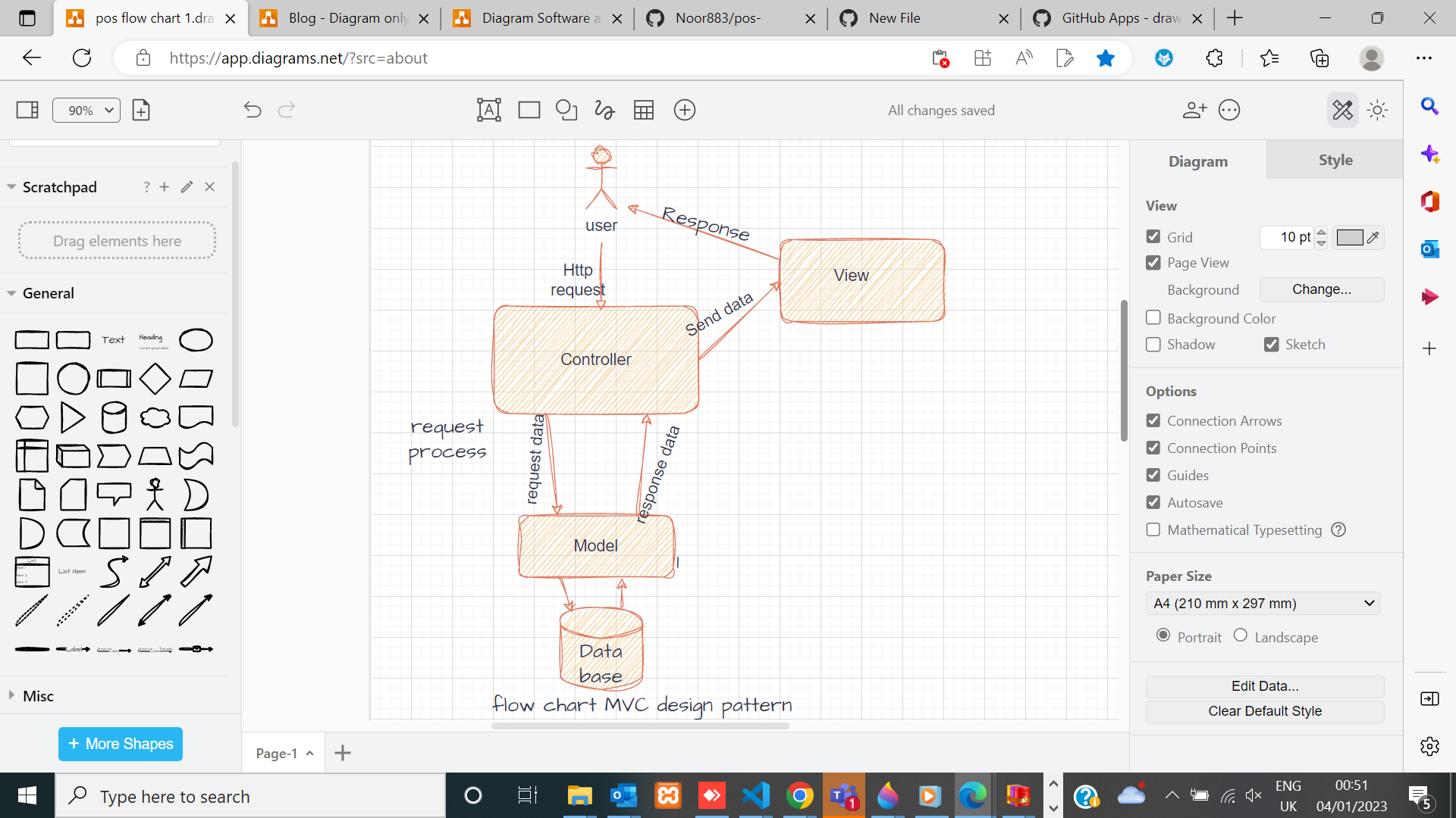

**Figure (1) Pos based MVC pattern**

**Definition:**

**Point Of Sale (POS):**

**It stands for Model, View & Controller.**

**The controller mediates between the models and views.**

**Also This app contains an API to respond to AJAX requests**

**jQuery ,bootstrap as libraries.**

* **ability to design a frontend webpage using HTML,CSS  
  and back-end in validation  
  security on remember me (Cookies) & login**

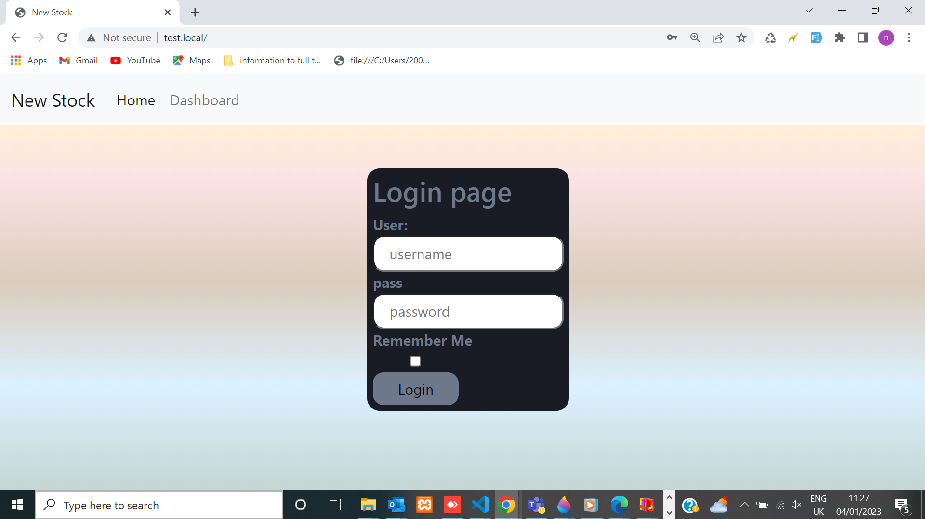

**Figure (2)log in page**

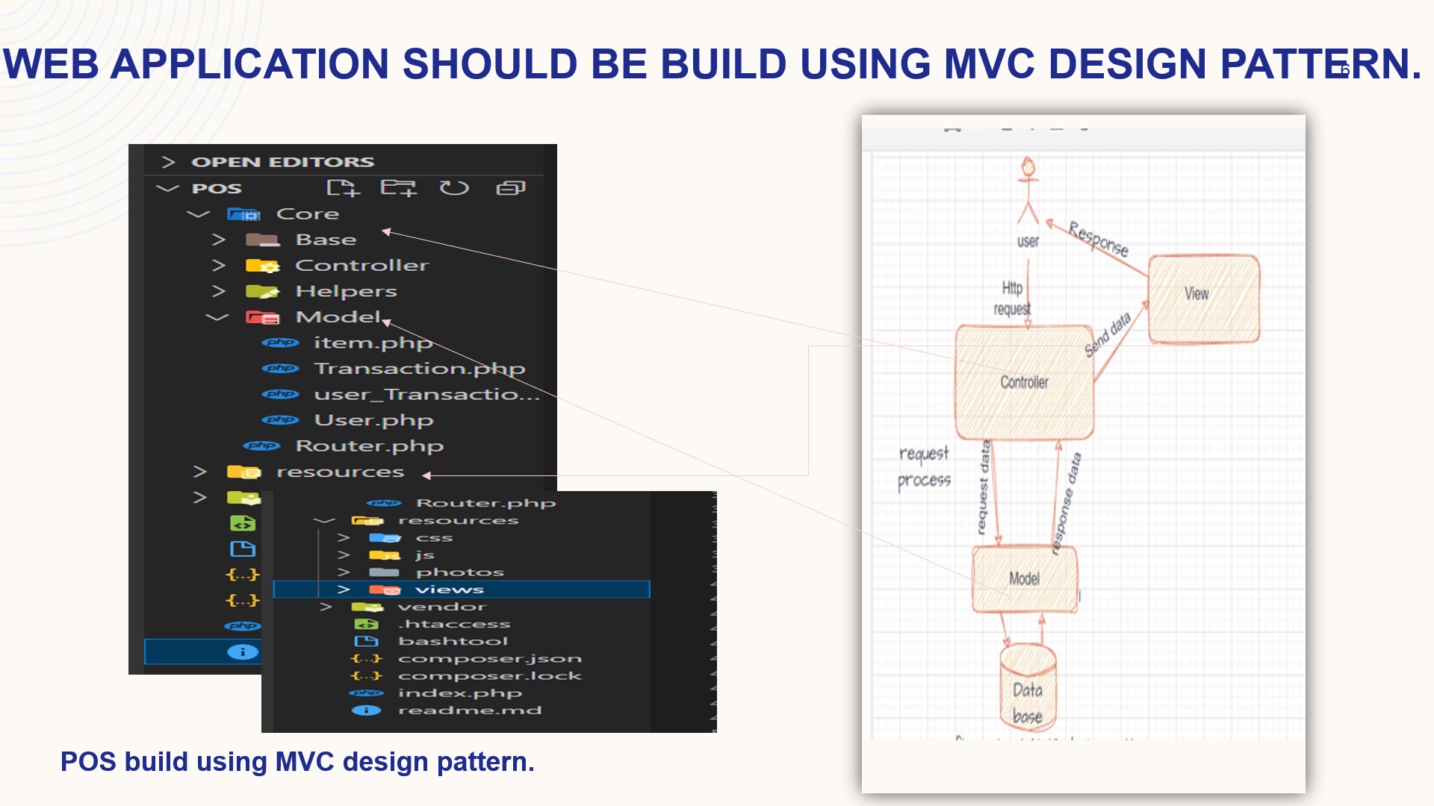

**Figure (3) Pos build using MVC design pattern**

Informative dashboard:

**Dashboards are set of information including details from content and navbar , logout profile & enter to more pages by menu**

**APP dashboard contains :** **screen dashboard &menu  
1.total items.  
2.total users.  
3.total transactions.  
4.total sales.  
5.**Top five expensive items to buy

**6. Menu .**

**7.Profile &**

**implementation during point of sales website App.**

**Profile page :**

it Found on navigation bar , user can add has a profile page and each user that has picture and the user is able to update their information username, email, and display name and picture.

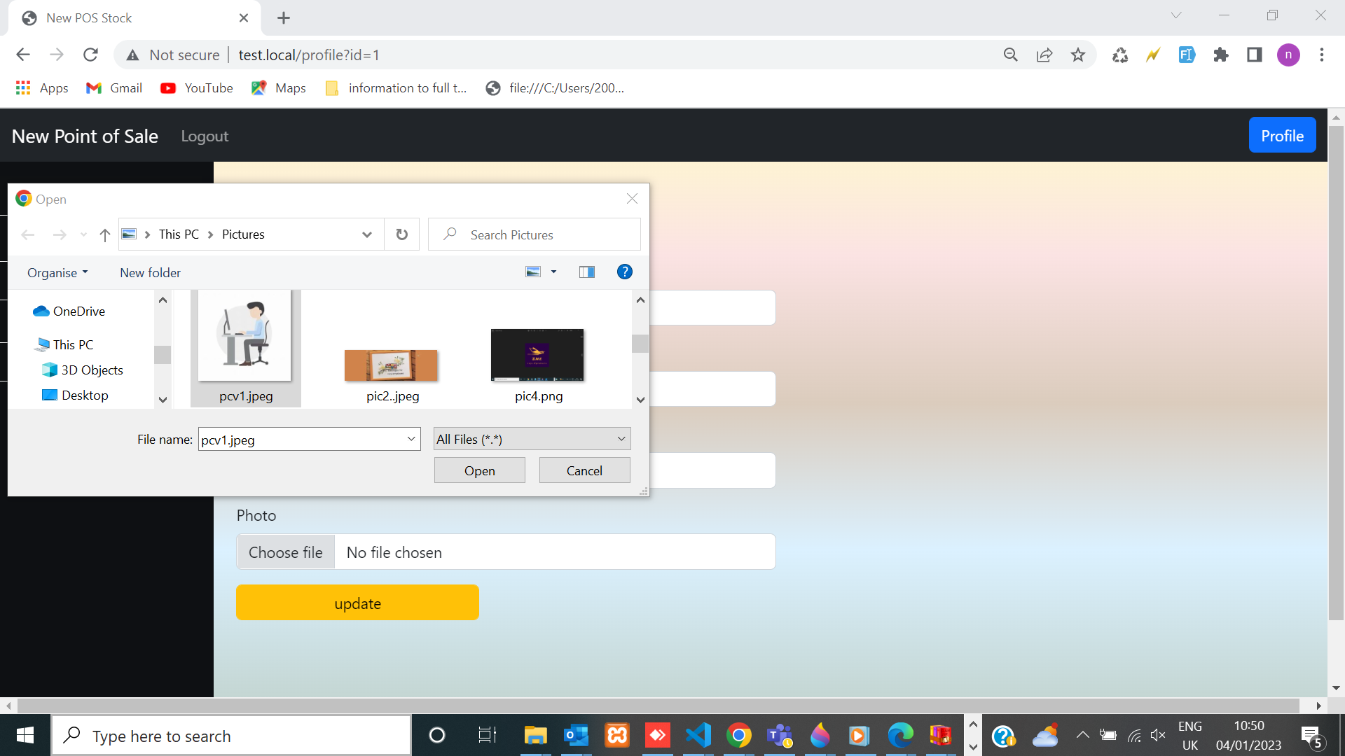

Figure (4) profile on dashboard with update on photo

each user that has picture and the user is able to update their information username, email, and display name and picture.

**Operations Occurred in Database (create, read, update and delete).  
will interact with the database .**

**We can display below pages within POS web :**

**stock management page :**

1. All Items list in stock management page .
2. Create item in stock management page.
3. When clicking on edit item, and updating the details,

then the item details will be changed .

1. Delete item.

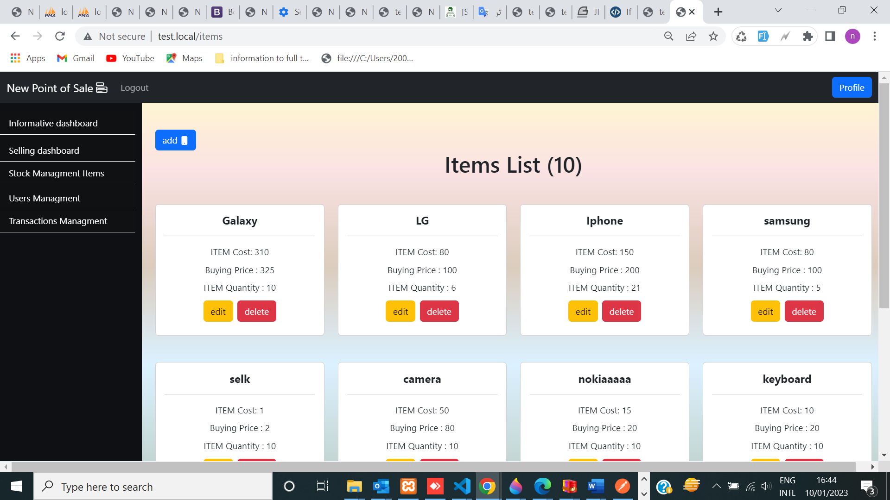

Figure (5) stock management page contain all items

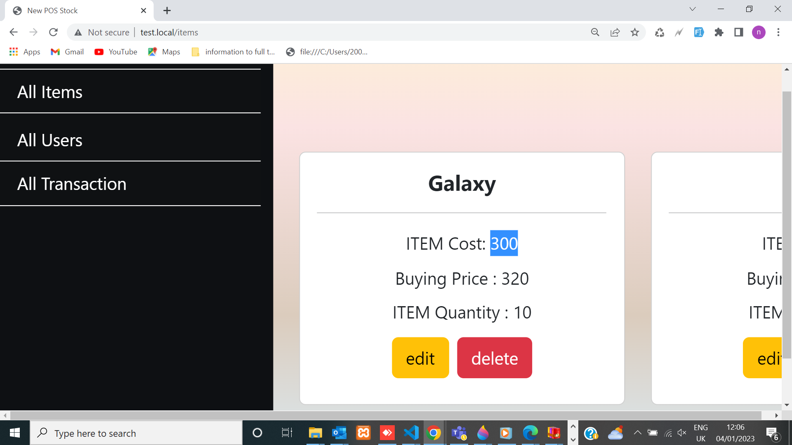

**Figure (5.1 ) one item**

**USERS PAGE with crud operation :**

* This page is implemented into fronted and back\_end in App POS
* I determined roles to all user as admin, seller, procurement or accountant.
* The Web App is connected with database by controller which interacts with model
* and the view is displaying through HTML template.

**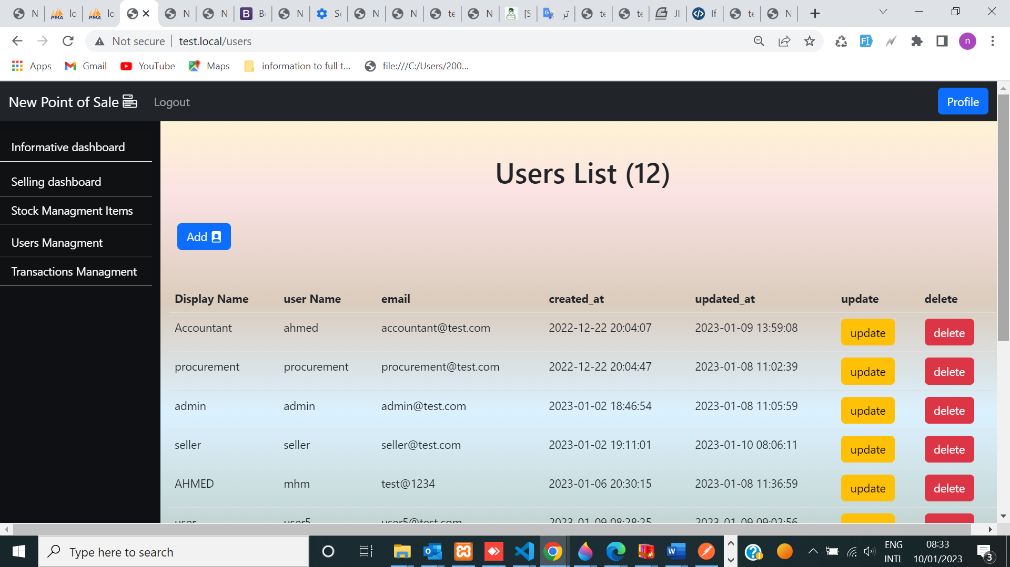**

**Figure (6) users list**

We can create user & determine permission through admin and

grant better security in APP ,



figure (6.1)create User .

* I can Edit(Update) user

& determine permission through admin and grant better security in APP.

**JavaScript**  is a client-side scripting language. It is executed on the client side by the web browsers that support JavaScript. JavaScript code only works in browsers that have JavaScript enabled.

**Router handling AJAX request**

How work Router in all API with ajax json data type with jQuery and solution give example to enter data front and save in database as chose 2 items and 2 items other and save as transaction how solution in back

Routers are used to route HTTP requests to the appropriate handler function. In a web application, the router is responsible for mapping URLs to specific actions that need to be taken.

In an API, the router is responsible for directing incoming HTTP requests to the correct handler function for processing and returning a response.

To use a router in an API with Ajax and jQuery, you can define the routes in your server-side code and then use jQuery's $.ajax function to send HTTP requests to those routes.

// Define the route for creating a new transaction

Router. post('/transactions', controller. Create Transaction);

// Export the router

module. exports = router;

Copy code

// Client-side code

// Set up the data to be sent with the request

const data = {

item1: 'healthy food',

item2: 'other food'

};

// Send the request to create a new transaction by ajax api

**$.ajax({**

**type: 'POST',**

**url: '/transactions',**

**data: JSON. Stringify (data),**

**content Type: 'application/json',**

**success: function(response) {**

**console.log ('Transaction created successfully');**

**}**

**});**

Part code

// **Import the router and the controller function that will handle the request**

**const router = require('express'). Router ();**

**const controller = require('./controller');**

// Send the request to create a new transaction

In this example, the router is defined to **handle** a POST request to the /transactions route.

When the request is received, the router will call the create Transaction function in the

**controller**, which is responsible for handling the request and saving the new transaction to the database.

The client-side code sends a POST request to

the /transactions route, along with the data for the new transaction as a JSON object.

This app contains an API to respond to AJAX requests.

**Here is an outline of the steps you can following :**

* Create a route in your server-side code that returns a list of transactions for the current logged in user.
* This route should accept a GET request and return the list of transactions as a JSON object.
* In your client-side code, Use jQuery to send an Ajax request to the server-side route whenever the page loads or
* when the user takes a specific action (e.g. clicking a button).
* In the success call back for the Ajax request,
* Use jQuery to parse the JSON response and update the page with the list of transactions.
* You can use a template (html form) or loop through the list of transactions and create new elements for each one.

**Implementation Selling dashboard using:**

**API, JSON, JS and jQuery ,API ajax as front-end and back-end php oop contain (Total sales ,Item , Quantity ,Price per unit, Total ).**

**and it is connected with transaction and saved in data base Using routes and name space**

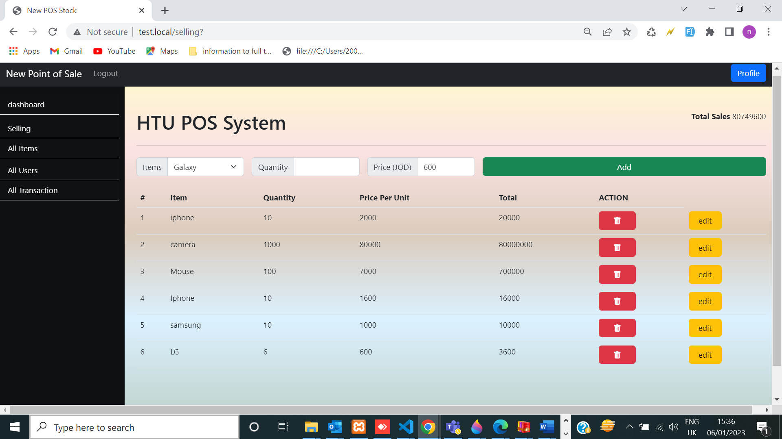

Figure (7) Selling dashboard.(Total sales ,Item , Quantity ,Price per unit, Total ).

* The admin of the POS system : wants to see a quick information of the total sales
* Implementation in pages . find top page of Selling dashboard.
* **The item and quantity are retrieved from database,**
* -The seller can’t sell items that is out of stock quantity.

Ex : lG quantity = 6 , and if the quantity is higher than 6, then it will not be calculated because It is not existed in the stock.

List of transactions that are created on the page by user will be saved in database, also, it will be displayed in transaction management page.

* **Implementation**
* **The Total Sales will display the total amount price for quantity of every item.**
* **Based on above info. the admin of POS system can see a quick information of the total sales on top of the page.**
* This dashboard contains **selling form** with following components (Item name , item quantity ,price per unit ,Total Sales).

When clicking on Add event, transaction list will be created.

* The total price is calculated by multiplying item’s quantity with it’s price.
* Transaction page will be created from Selling Dashboard
* There should be a list in the same page for all the transactions saved in transaction management page and in data base . With update & delete in one transaction & saved in data base and we can edit or delete each transaction on this list directly using action buttons.

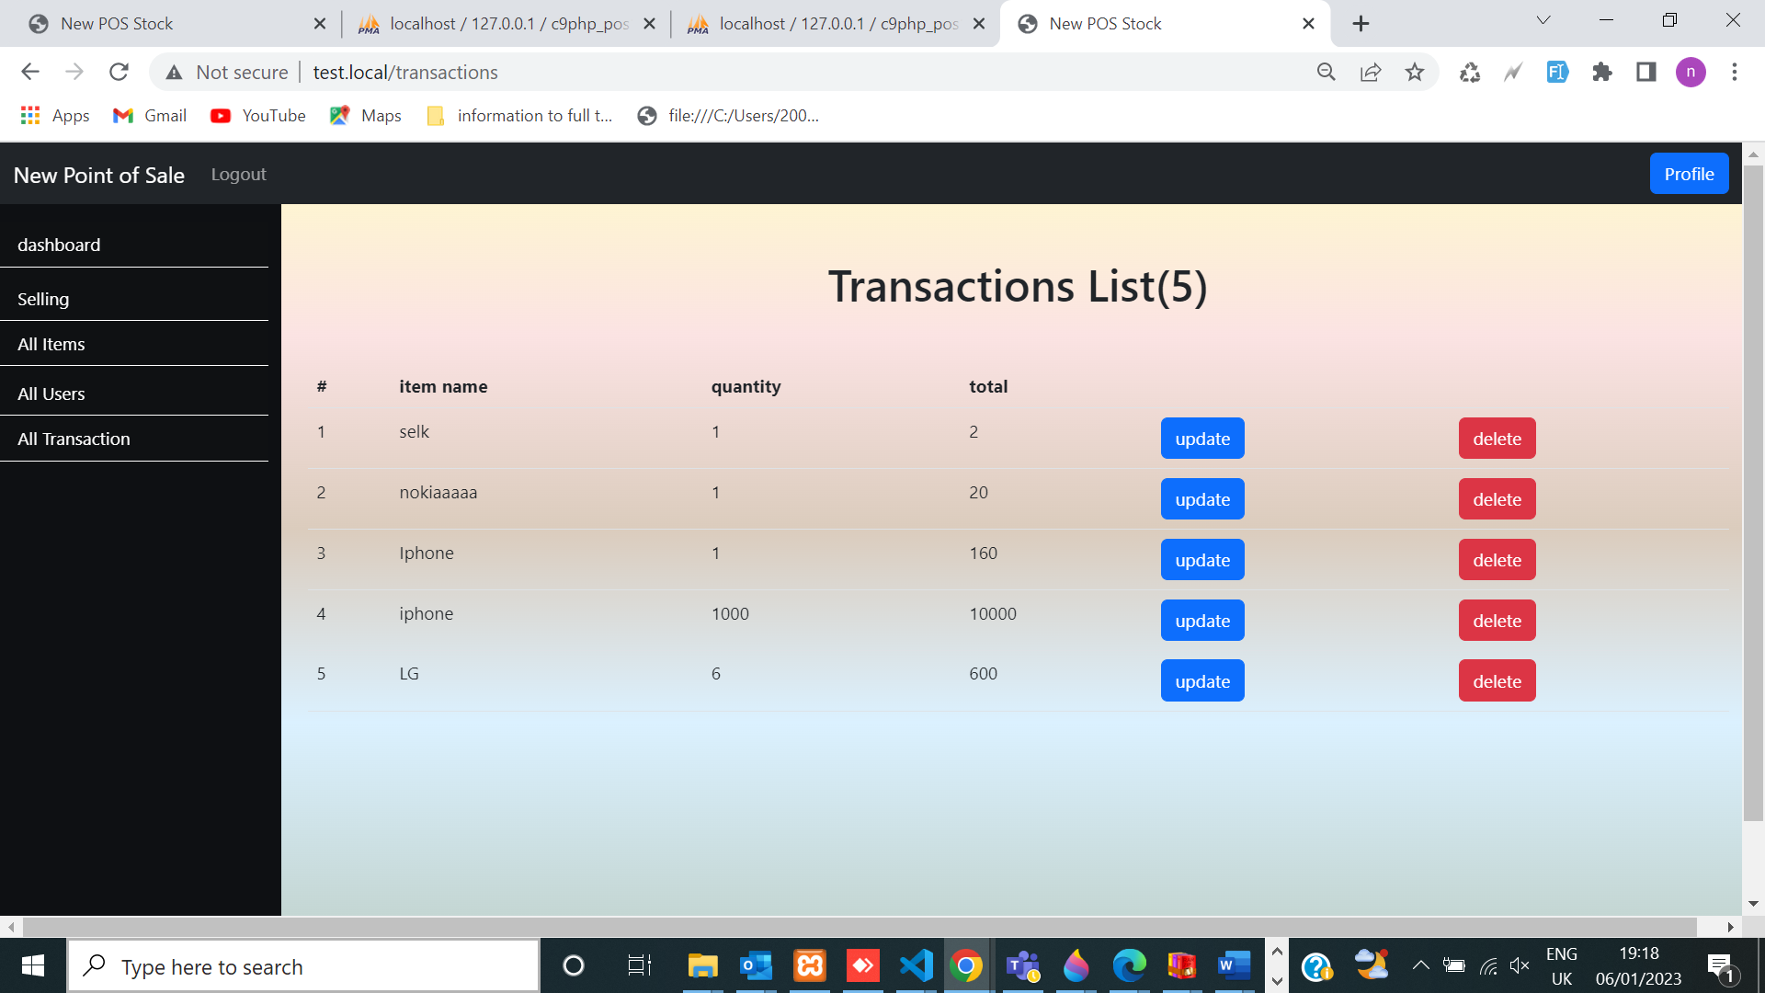

**figure (8) Selling dashboard Join with data transactions list ( same data in 2 pages ).**

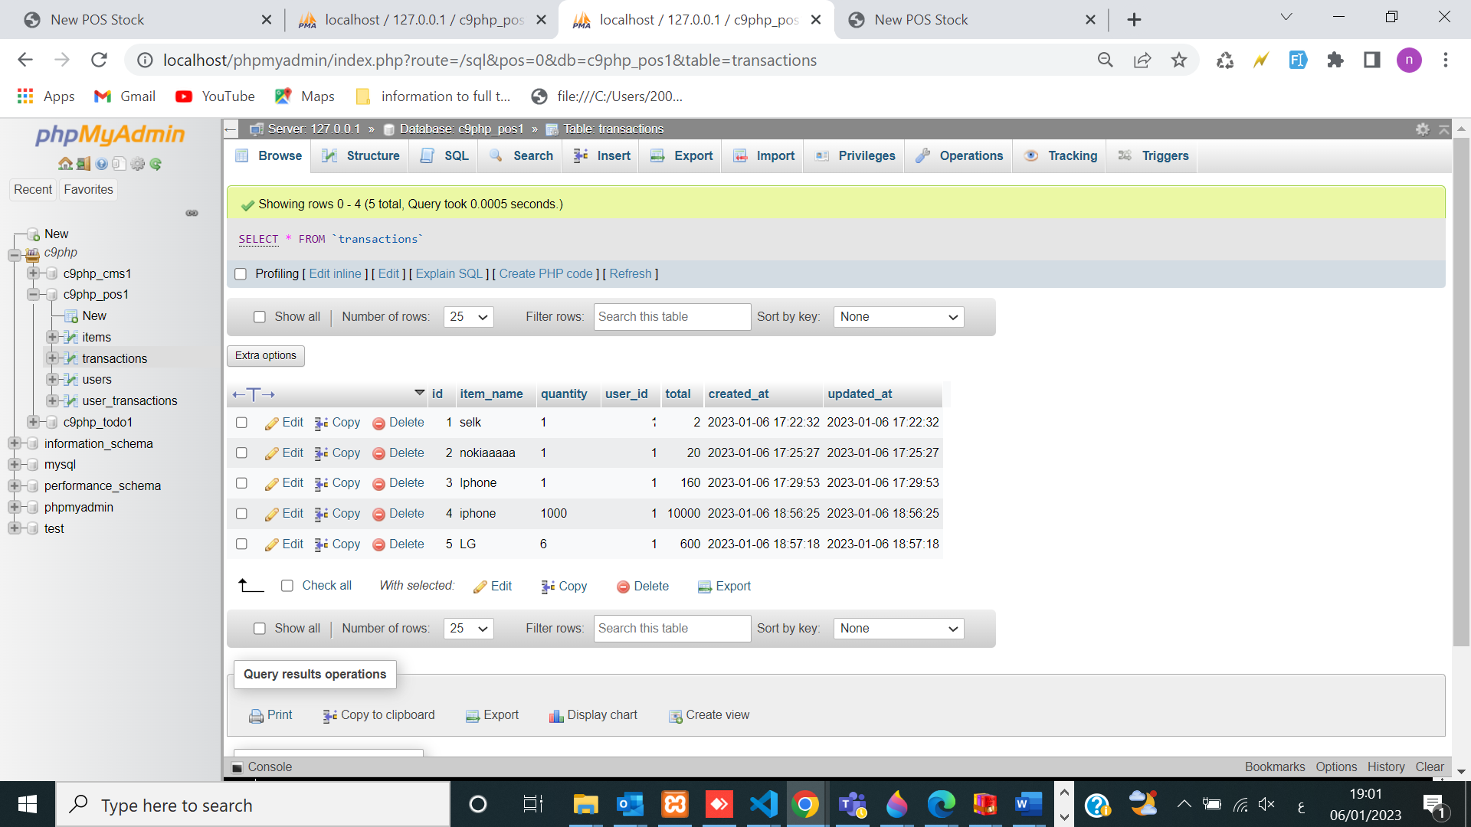

**Figure (9 ) Saving Selling dashboard in data base.**

**transaction management page**

will create selling dashboard join with **transaction management page** . There should be a list in the same page for all the transactions saved in transaction management page and in data base . With update & delete in one transaction & saved in data base and we can edit or delete each transaction on this list directly using action buttons.

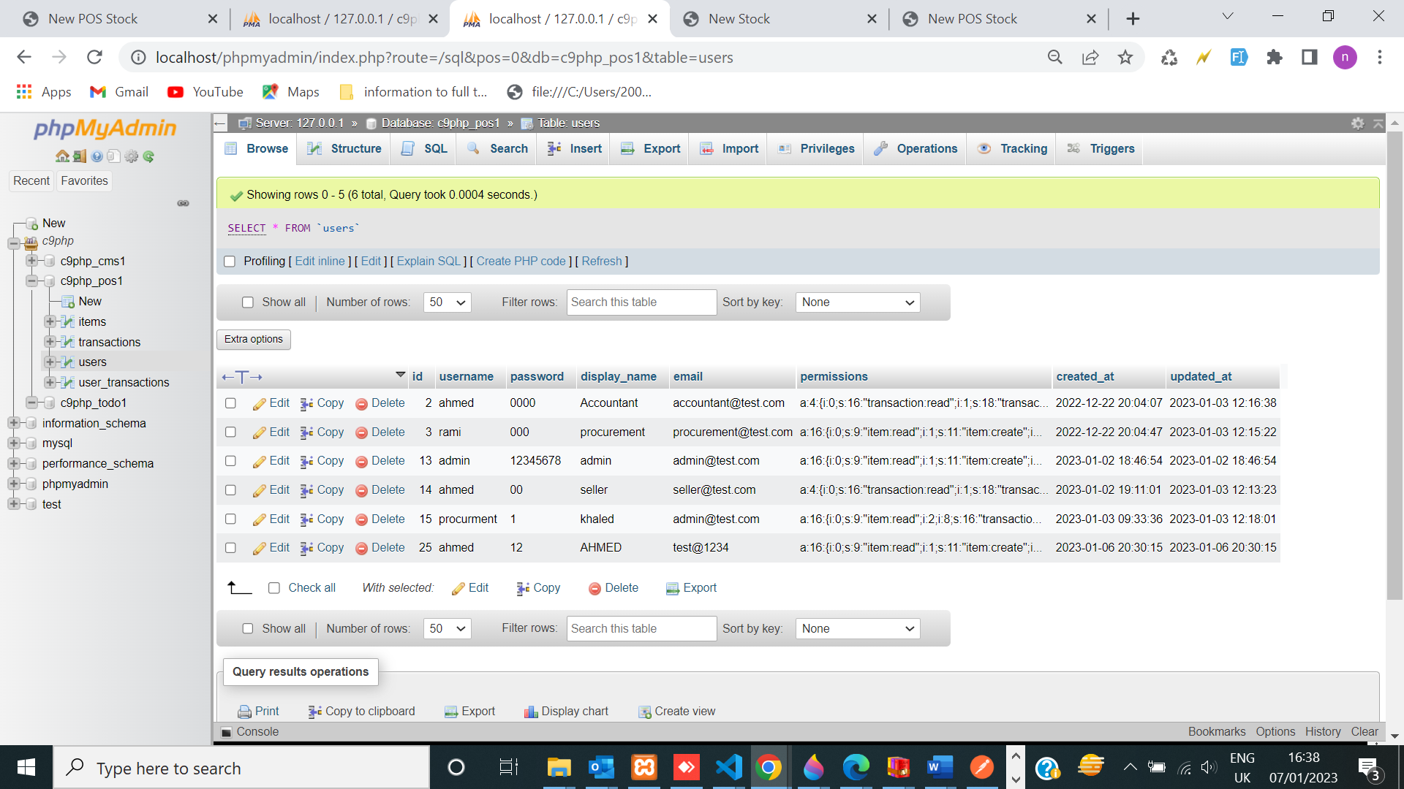

Figure (10) security implement ( role (permission))

* Users to access pages as per their roles: (Roles be hard coded and the app be controlled based on permissions)

Benefits of using mvc architecture effect on project

* Logical clustering of related acts on any controller can be achieved through MVC.
* Various developers can work at the same time on different parts the same application-controller, model, and the views part.
* In MVC, models can have numerous views.

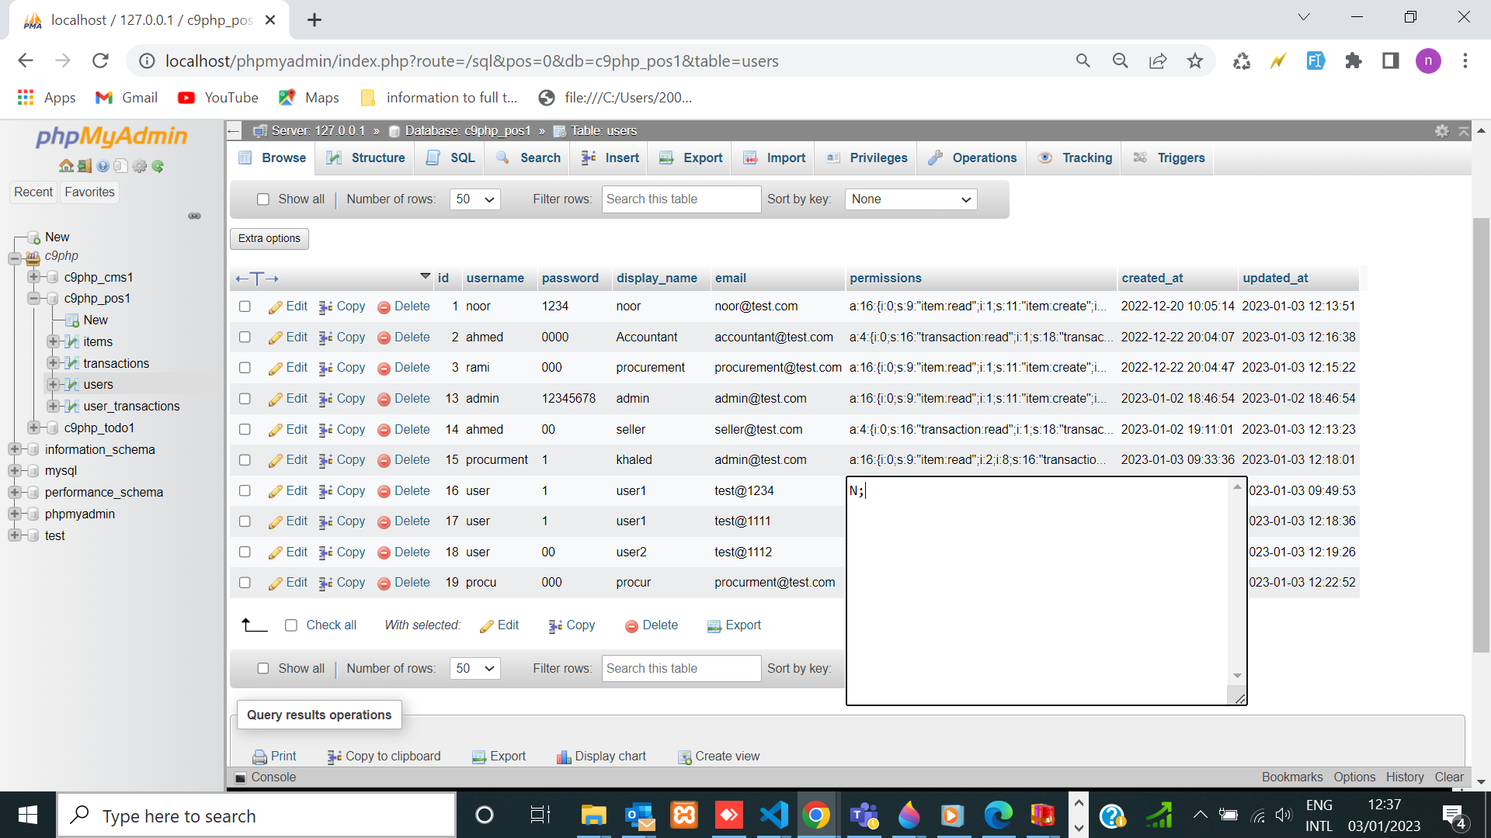

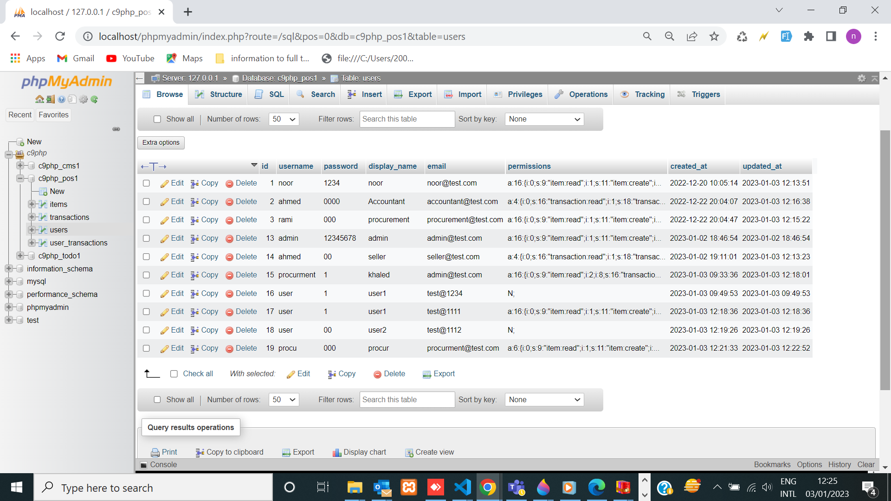



Figure (11) grant permission

outline :

* serialize (generates a strong able representation of a value ) here array convert value role to value permission to as string . and used unseralize to convert to array in project .
* Representing permission with passworded hash Algorithm to encrypt the password

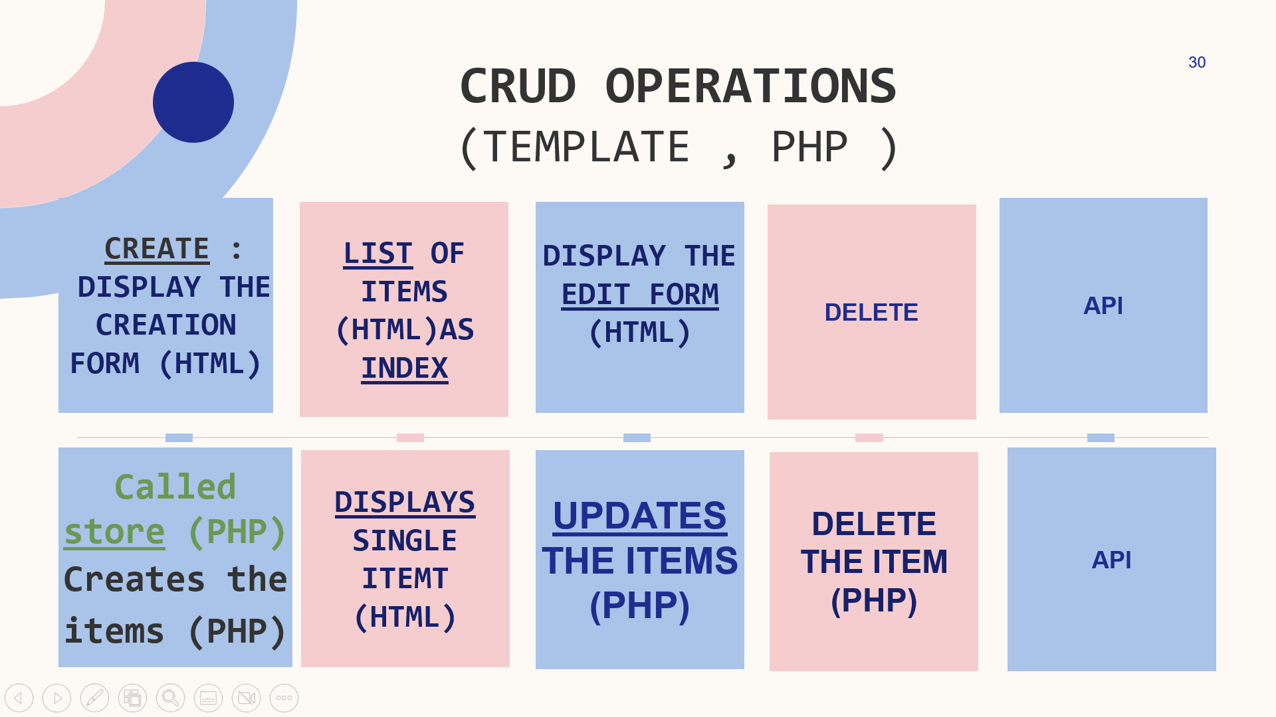

Figure (12 ) outline crud operating on project

the following 3 types of security are currently supported in POS :

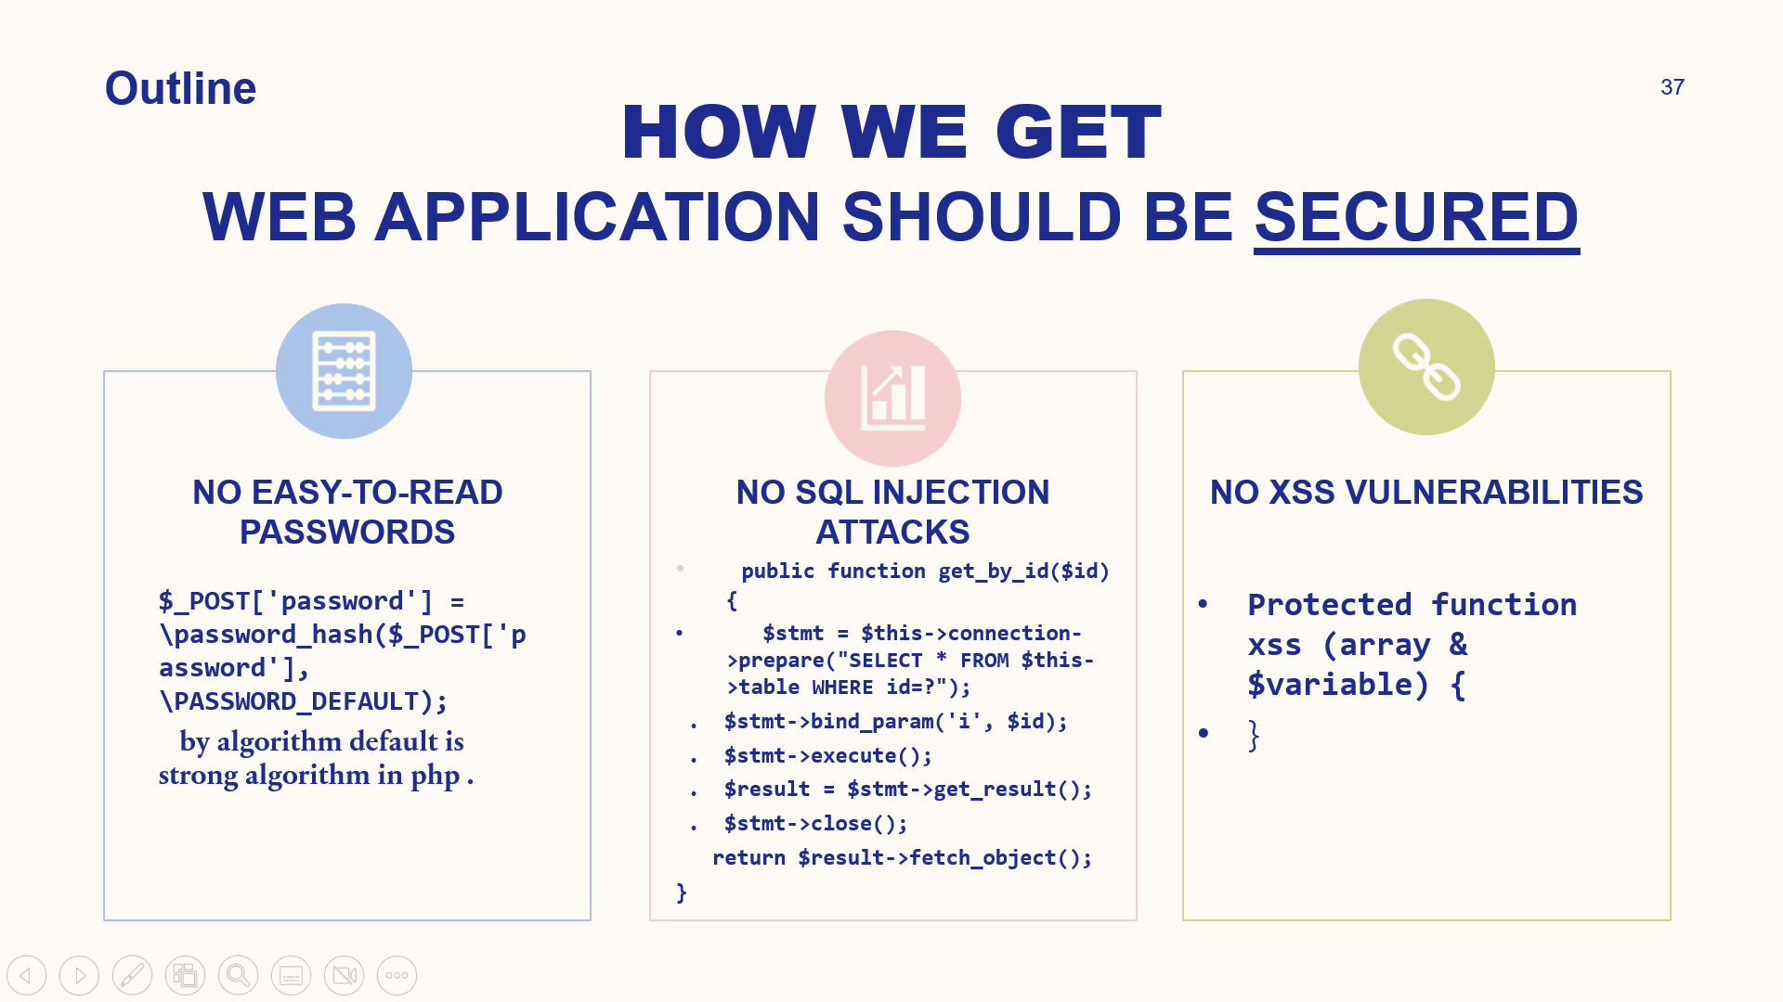

Figure (13) secured

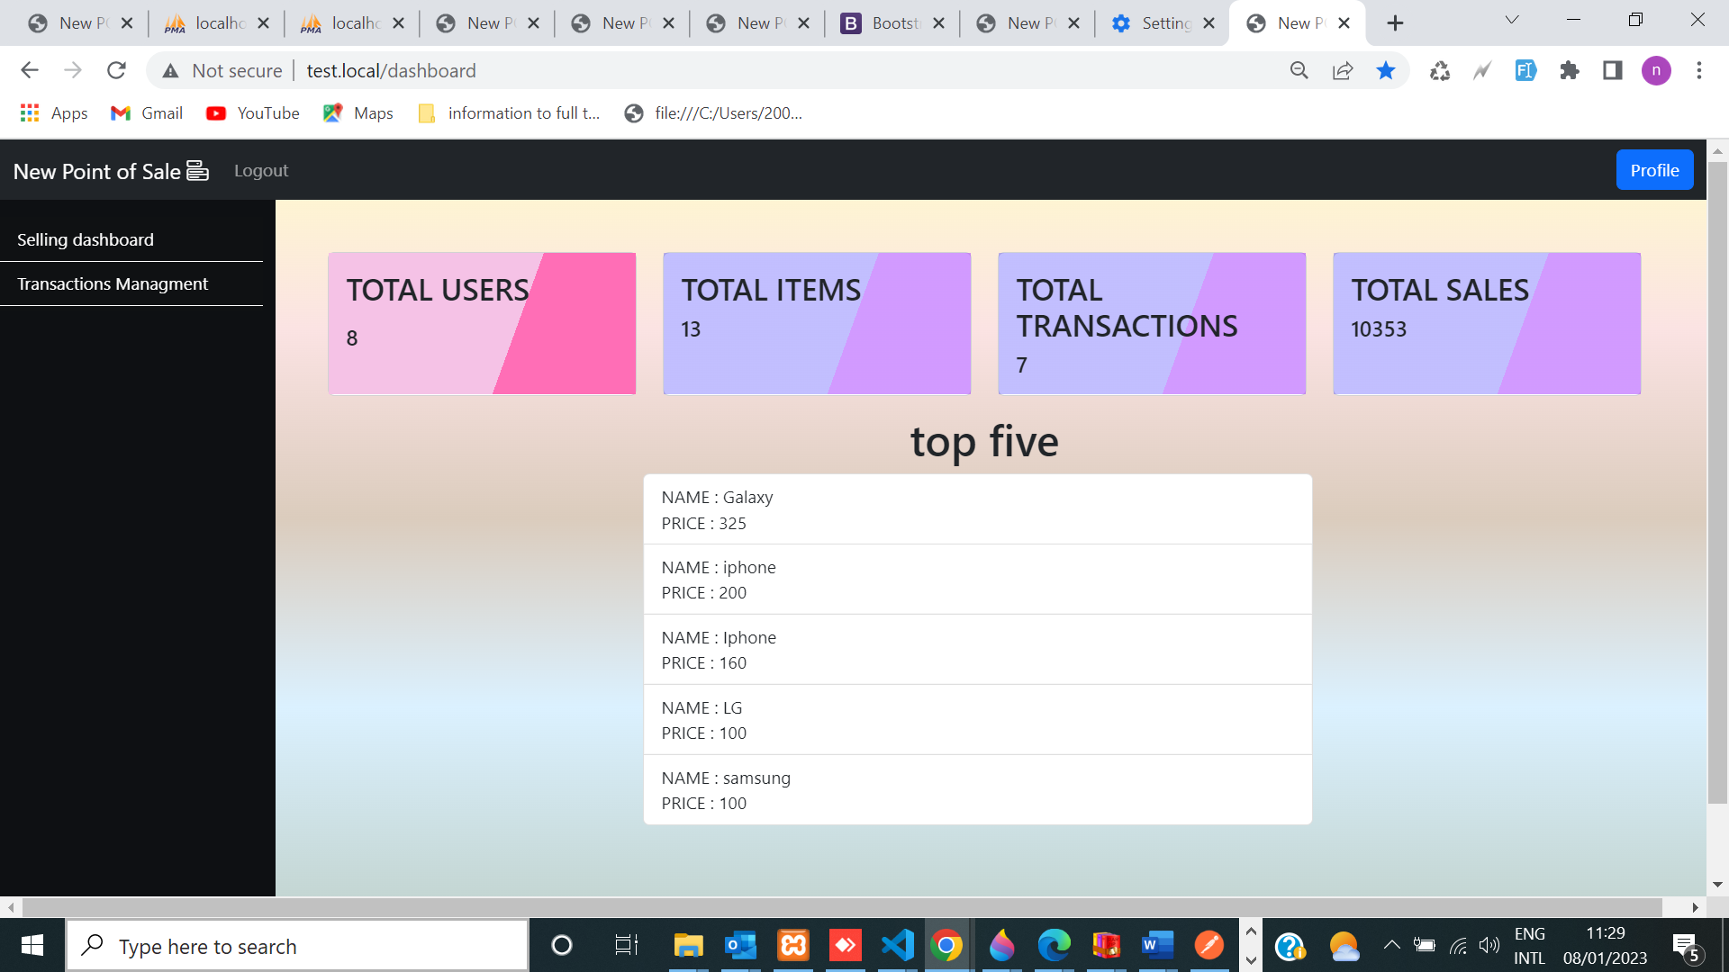

Figure (14)use permission with cookie (seller)

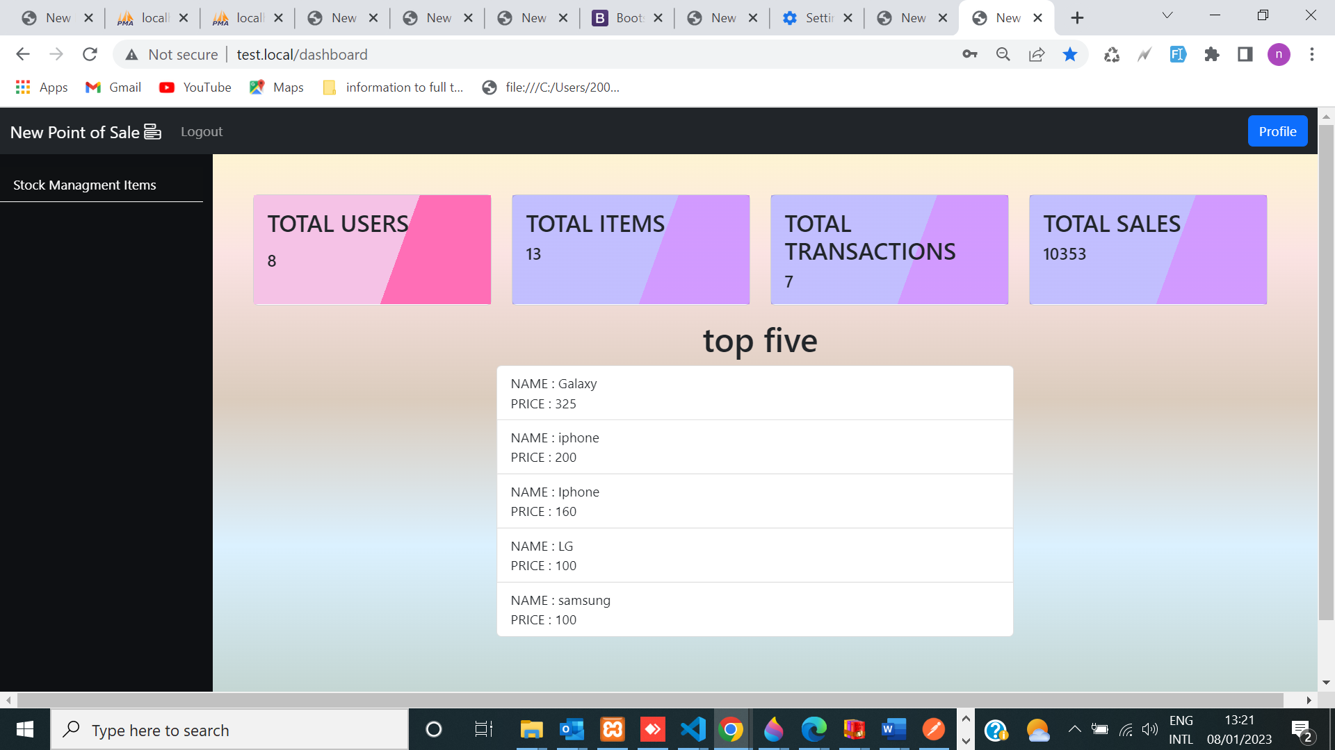

Figure (15) represent procurement with permission with code password hash



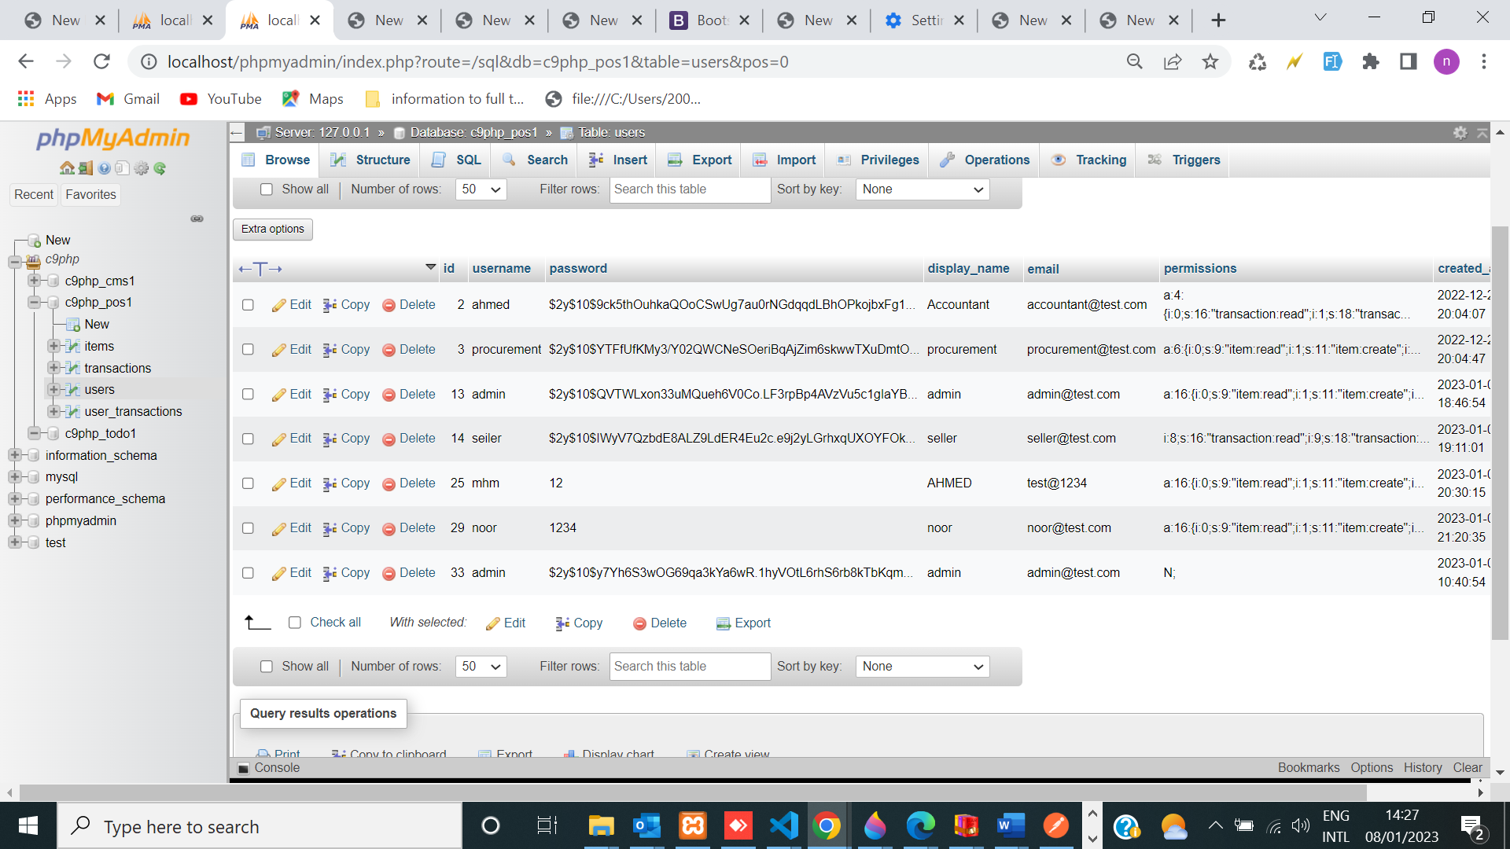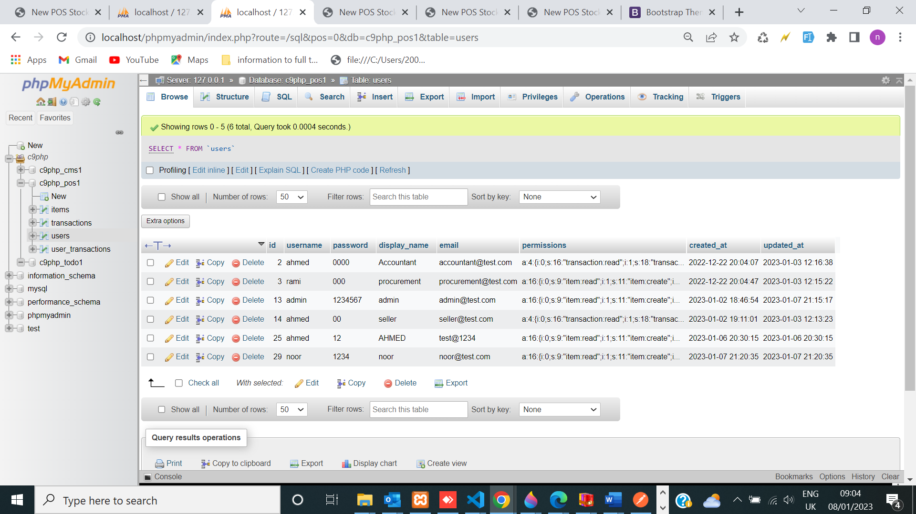

Figure(16 ) use security serialize and hash password

**CONCLUSION:**

* **I have realized that (POS) Point Of Sale Web Application** is an application that is implemented using MVC design pattern which separates the application data and business logic (model) from the presentation (view) which means that the client layer does not communicate directly with the data layer and It must pass through an intermediate layer.

Reference :

[1][Model–view–controller - Wikipedia](https://en.wikipedia.org/wiki/Model%E2%80%93view%E2%80%93controller)

[2]<https://www.giuseppemaccario.com/how-to-build-a-simple-php-mvc-framework>

[3]<https://www.guru99.com/>

[4]<https://www.w3schools.in/>

[5]<https://www.w3programmers.com/>

[6] [Naked objects - Wikipedia](https://en.wikipedia.org/wiki/Naked_objects)

[7] <https://www.tutorialsteacher.com/webapi/create-web-api-for-crud-operation>

[8] [Cross-site Scripting (XSS)](https://www.invicti.com/learn/cross-site-scripting-xss/) is a client-side code [injection attack](https://www.acunetix.com/blog/articles/injection-attacks/).